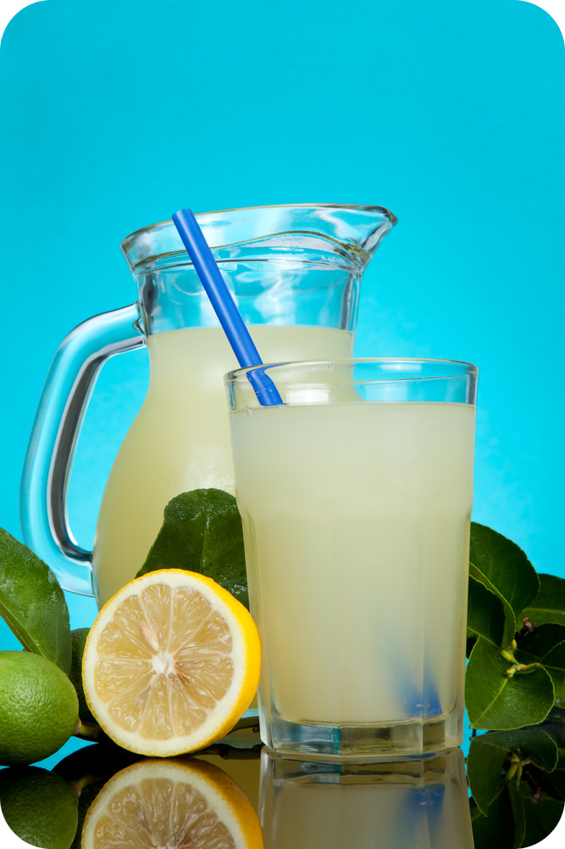
MIxtures Reading Packet

What Is a Mixture?
A mixture is a combination of two or more substances in any proportion. This is different from a compound, which consists of substances in fixed proportions. The substances in a mixture also do not combine chemically to form a new substance, as they do in a compound. Instead, they just intermingle and keep their original properties. The lemonade pictured to the right is a mixture because it doesn’t have fixed proportions of ingredients. It could have more or less lemon juice, for example, or more or less sugar, and it would still be lemonade.

Homogenous or Heterogenous?

The lemonade in the opening picture is an example of a homogeneous mixture. A homogeneous mixture has the same composition throughout. Another example of a homogeneous mixture is salt water. If you analyzed samples of ocean water in different places, you would find that the proportion of salt in each sample is the same: 3.5 percent.
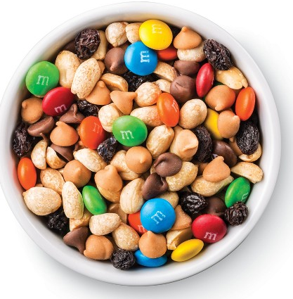
The trail mix is an example of a heterogeneous mixture. A heterogeneous mixture varies in its composition. The peanuts, raisins, cashews and M&Ms, for example, are not distributed evenly throughout the trail mix.

Types of Mixtures

Mixtures have different properties depending on the size of their particles. Three types of mixtures based on particle size are solutions, suspensions, and colloids.

What is a Solution?
A solution is a mixture of two or more substances, but it’s not just any mixture. A solution is a homogeneous mixture. In a homogeneous mixture, the dissolved particles are spread evenly through the mixture. The particles of the solution are also too small to be seen or to settle out of the mixture.

Parts of a Solution
All solutions have two parts: the solute and the solvent. The solute is the substance that dissolves, and the solvent is the substance that dissolves the solute. Particles of solvent pull apart particles of solute, and the solute particles spread throughout the solvent.
Salt water, such as the ocean water in the picture below, is an example of a solution. In a saltwater solution, salt is the solute and water is the solvent.
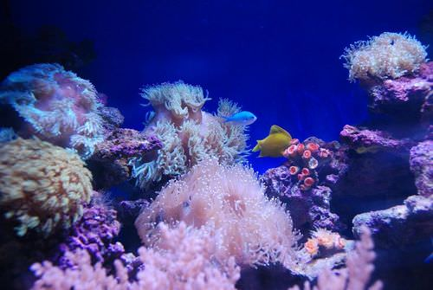

Soluble or Insoluble?
Not only salt, but many other solutes can dissolve in water. In fact, so many solutes can dissolve in water that water has been called the universal solvent. A solute that can dissolve in a given solvent, such as water, is said to be soluble in that solvent. Conversely, a solute that cannot dissolve in a given solvent is said to be insoluble in that solvent.

What is a Suspension?

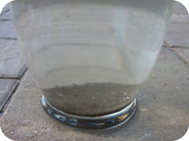
Take a glass of water and throw in a handful of sand or dirt. Stir it and stir it and stir it. The water may become turbid, or unclear. Have you made a solution? Sand and dirt do not dissolve in water and though it may look homogeneous for a few moments, the sand or dirt gradually sinks to the bottom of the glass.

A suspension is a heterogeneous mixture in which some of the particles settle out of the mixture upon standing. The particles in a suspension are far larger than those of a solution and thus gravity is able to pull them down out of the dispersion medium (water). Unlike in a solution, the dispersed particles can be separated from the dispersion medium by filtering.

Dirt in water

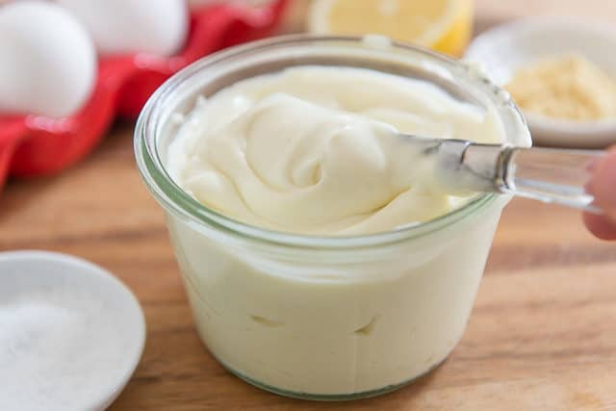
What is a Colloid?
A colloid is a heterogeneous mixture whose particle size is intermediate between those of a solution and a suspension. The dispersed particles are spread evenly throughout the dispersion medium, which can be a solid, liquid, or gas. Because the dispersed particles of a colloid are not as large as those of a suspension, they do not settle out upon standing. Mayonnaise and milk are examples of a colloids.

Summary:
- A mixture is a combination of two or more substances in any proportions. The substances in a mixture do not combine chemically, so they retain their physical properties.
- A homogeneous mixture has the same composition throughout. A heterogeneous mixture varies in its composition.
- Mixtures can be classified on the basis of particle size into three different types: solutions, suspensions, and colloids.
- A solution is a homogeneous mixture of two or more substances in which the dissolved particles are too small to be seen or to settle out of the mixture.
- In a solution, the substance that dissolves is the solute, and the substance that dissolves the solute is the solvent.
- A solute that can dissolve in a given solvent is said to be soluble in that solvent. A solute that cannot dissolve in a given solvent is said to be insoluble in that solvent.
- Solutions may be liquids such as salt water, solids such as alloys, or gases such as air.
- Suspensions are heterogeneous mixtures.
- Some of the material in a suspension will settle out on standing.
- Solid material in a suspension can be removed by filtration.
- Colloids are heterogeneous mixtures with particles that do not settle out. They are in between solutions and suspensions.

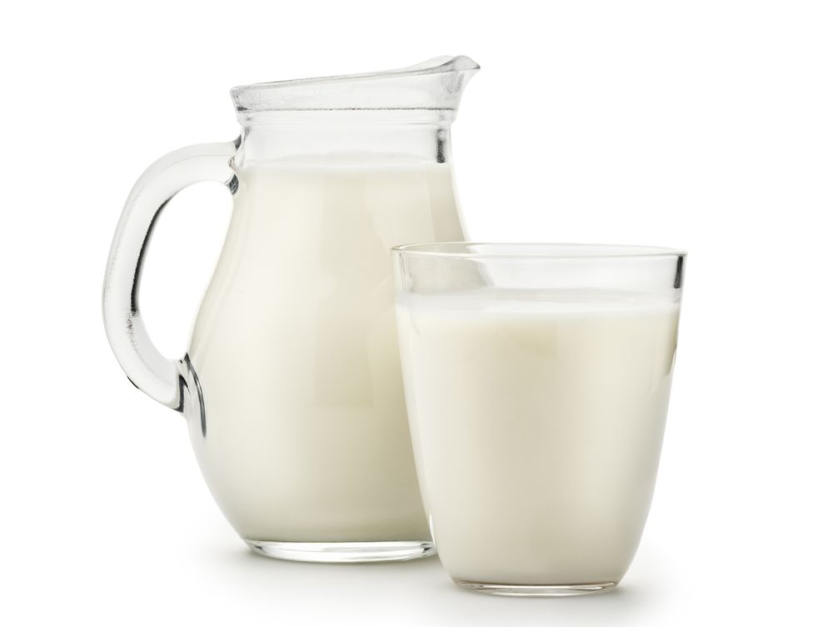
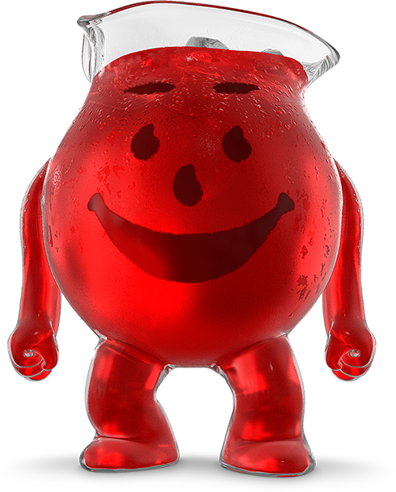
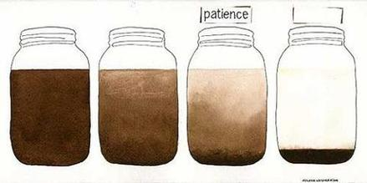

Kool Aid - Solution Milk - Colloid Dirt in water - Suspension

